Individual Devotions for Good Enough

Dear Ones - We are so pleased to be using the devotional book, Good Enough: 40’ish Devotionals for a Life of Imperfection, as a guide for our worship this Lent. Each week we will be focusing on a concept from the book, and we invite you to use it as a daily devotional, with the exception of Sundays (this is traditionally how the “40 days of Lent” are calculated… and at some point, you’ll find the “40’ish-ness” where there is one more, which makes it perfectly imperfect).
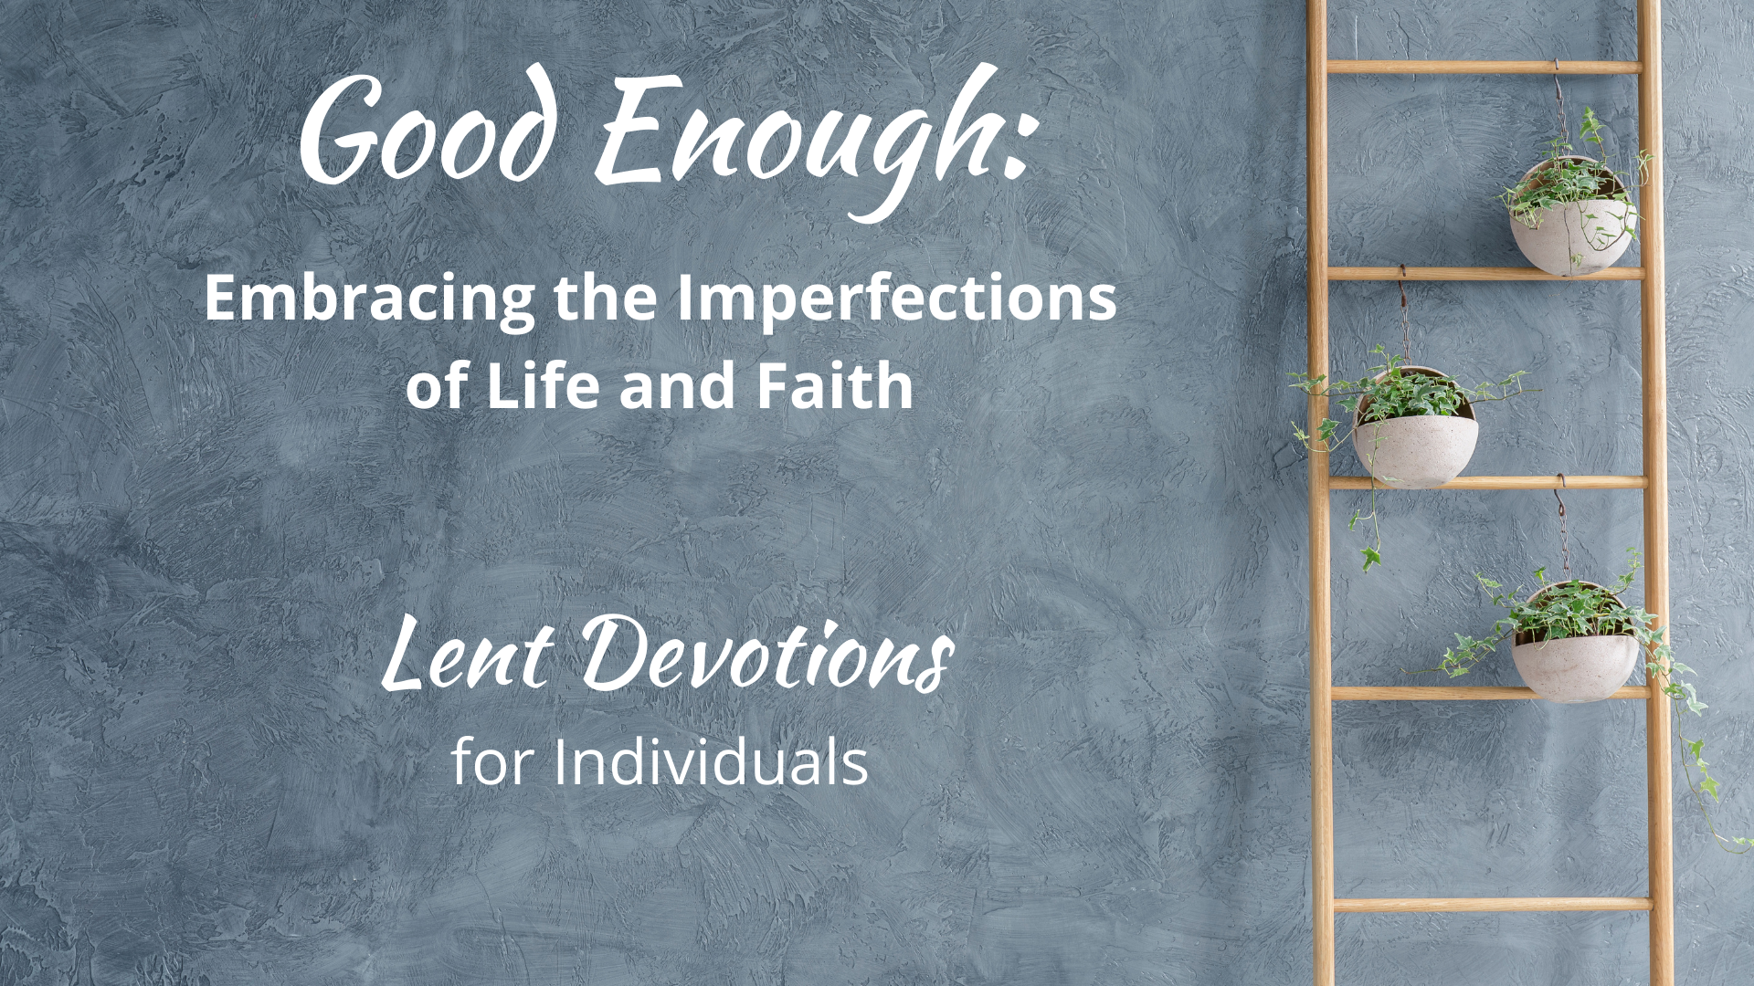
Within each week, you can read the listed devotions in any order, not just the order we have listed here. If a title catches your eye, trust that and go for it! There are check boxes to help you keep track of what you’ve read. Page numbers after each devotional title correspond to pages in the book. (You may have noticed, we will not be reading the devotions in the order they appear in the book, cover to cover, so follow this guide to be ready for discussion in your small groups!)

Selections for the days after Ash Wednesday |
“Perfectionism is impossible. Transformation isn’t.”

☐ Regula (3)
☐ When Good Things Become Burdens (45)
☐ Give Up Already (145)

Selections for the days after Lent 1 | "Ordinary lives can be holy.”

☐ Shiny Things (21)
☐ Building a Good Day (28)
☐ Small Things, Great Love (34)
☐ Happy Enough (61)
☐ No Reason Whatsoever (110)
☐ Mediocrity for the Win (161)

Selections for the days after Lent 2 | “So much is out of our control."

☐ Asleep on the Job (39)
☐ The Tragedy Olympics (86)
☐ Being Honest about Disappointment (134)
☐ Bottling Magic (179)
☐ Gondola Prayers (184)
☐ The In-Between (210)

Selections for the days after Lent 3 | “Lots of things can be medicine.”

☐ Buoyed by the Absurd (9)
☐ When You are Exhausted (56)
☐ Hopping off the Treadmill (98)
☐ Kindness Boomerangs (140)
☐ 2:00 AM/2:00 PM (205)
☐ Too Few Sparrows (215)

Selections for the days after Lent 4 | “We often believe we are the problem.”

☐ Needing Rules at All (74)
☐ For the Exiles (79)
☐ The Bad Thing (92)
☐ Becoming Real (117)
☐ To My Body (156)
☐ Refuge (173)

Selections for the days after Lent 5 | “We are fragile.”

☐ Right After It’s Over (68)
☐ Hello, Goodbye (103)
☐ Loving What Is (129)
☐ The Burden of Love (167)
☐ The Reality-Show Gospel (195)
☐ Bright Hope (220)

Selections for the days after Lent 6/Palm Sunday | “You are a group project.”

☐ The Foundation (51)
☐ Say Potato (150)
☐ The Cost of Caring (189)
☐ When Words Fail (200)

Selection especially for Maundy Thursday | “We are blessed, regardless.”

☐ #Blessed (122)

Selection especially for Good Friday | “Even today, God is here and somehow, that is good enough.”

☐ Mourning a Future Self (15)

Selection especially for Easter Sunday | “A Good Enough Faith"

- A Good Gardener (226)

